**Module 6 Activity 1: Protecting Resources**

Saurabh Kale

IFT 458/554: Middleware Programming & Database Security

Dinesh Sthapit

Oct 29th, 2023

**Module 6 Activity 1: Protecting Resources**

DateTime-

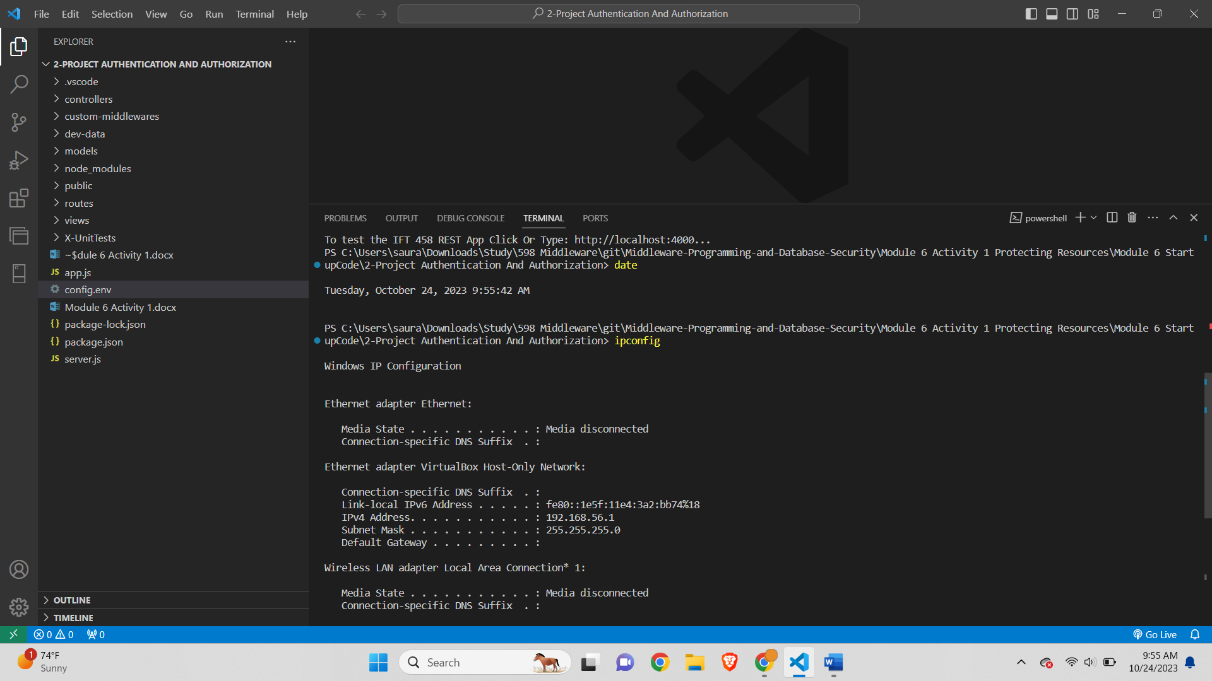

Ip-

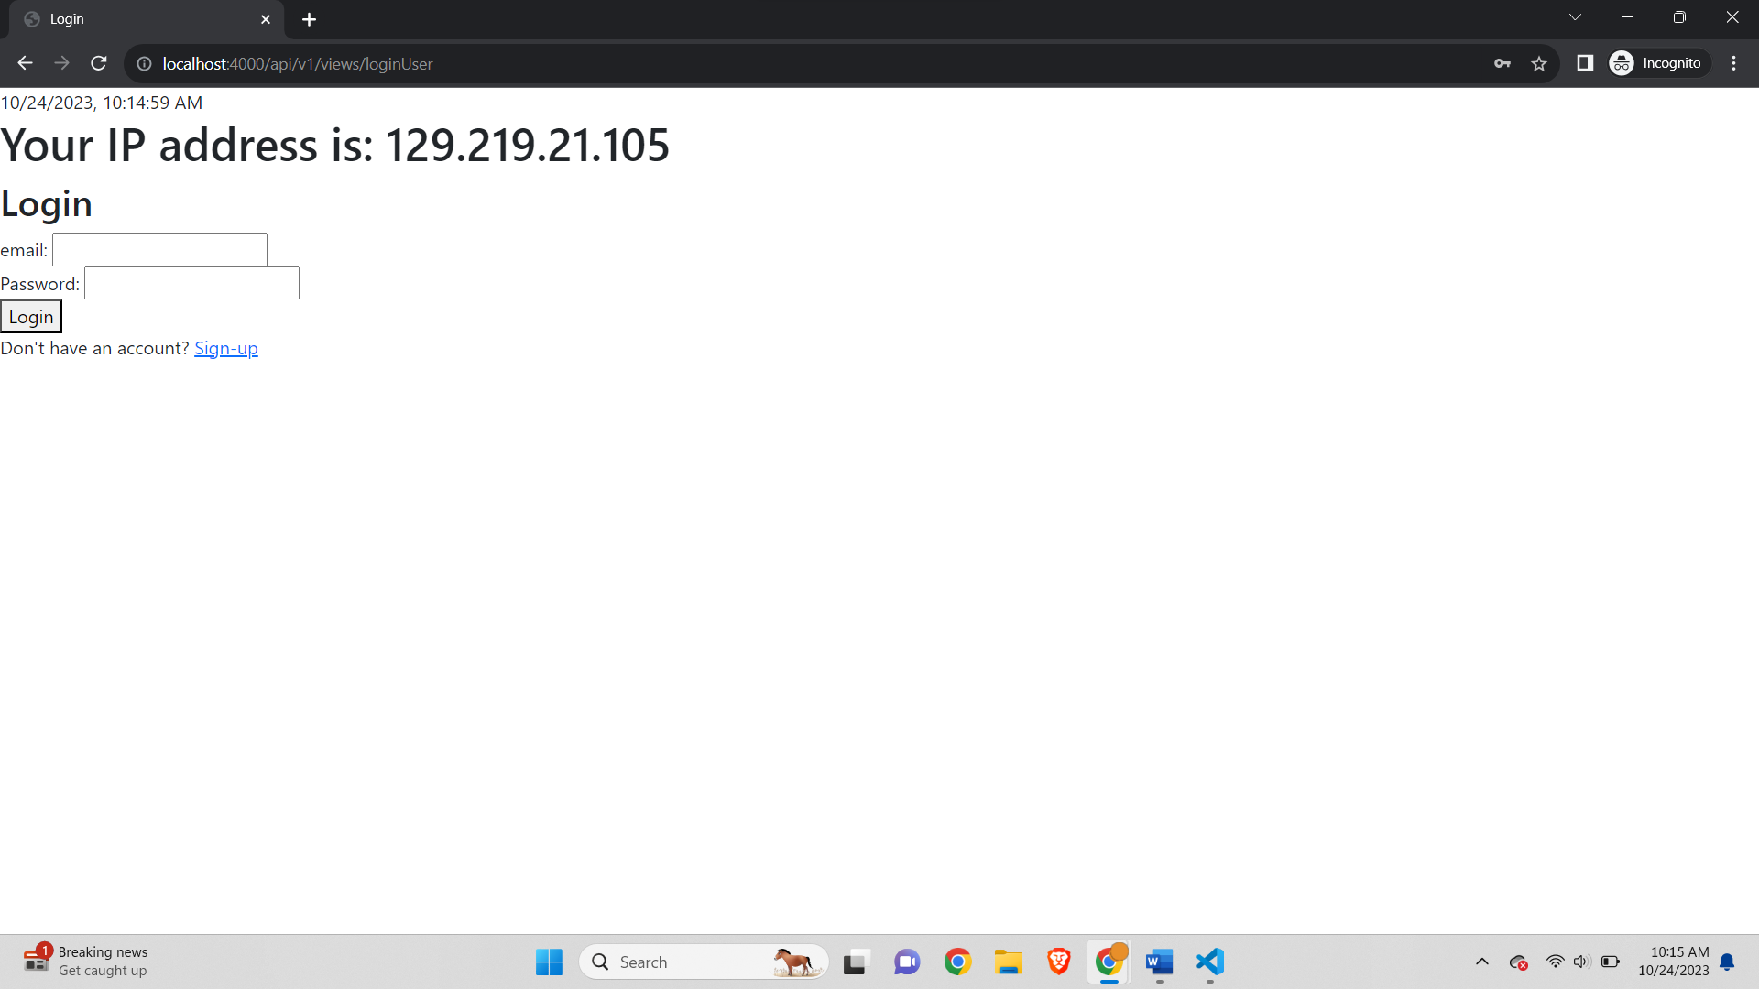

IP as half of the assignment is done from home so I will have 2 IP first half for college IP and second Half for Home IP-

IP (home)-

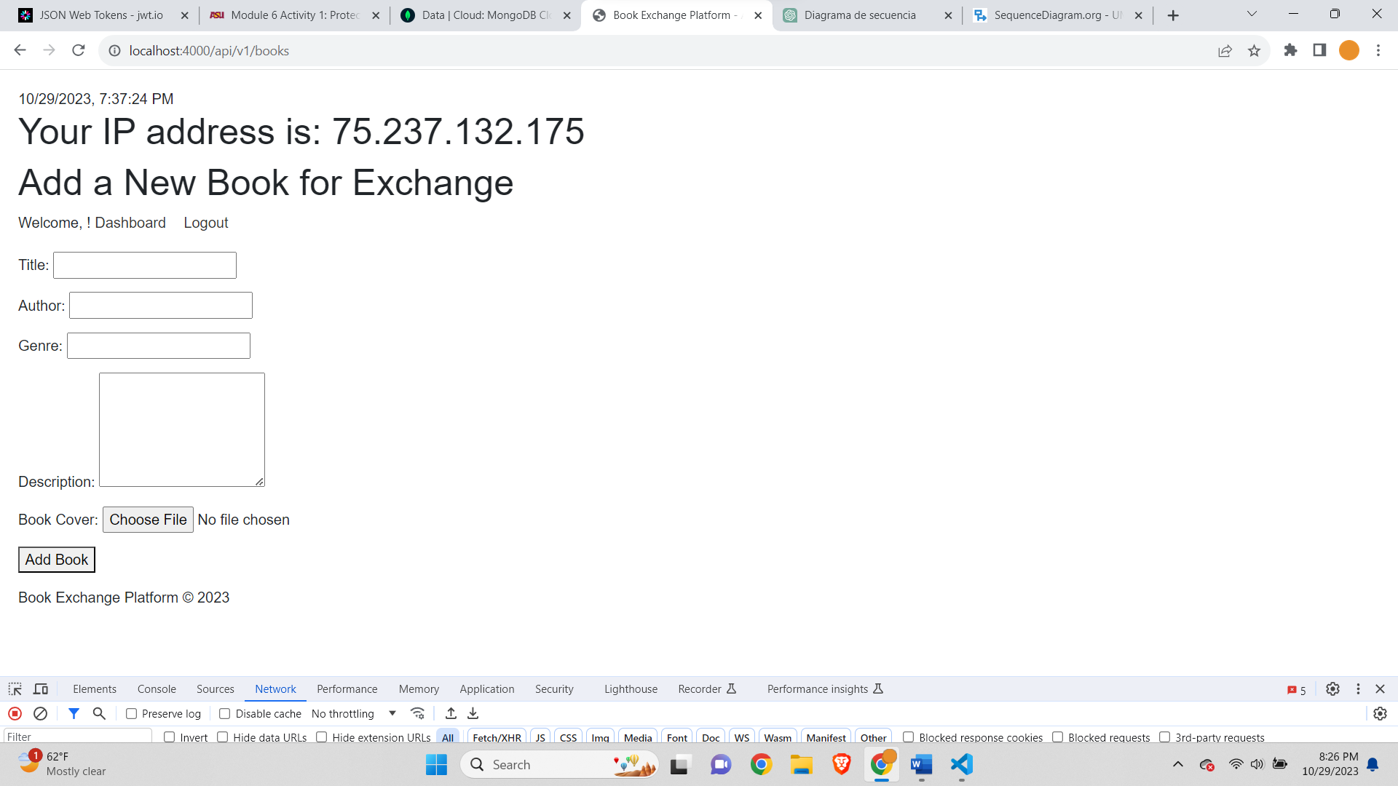

Step 1: Downloading the code and restoring the project

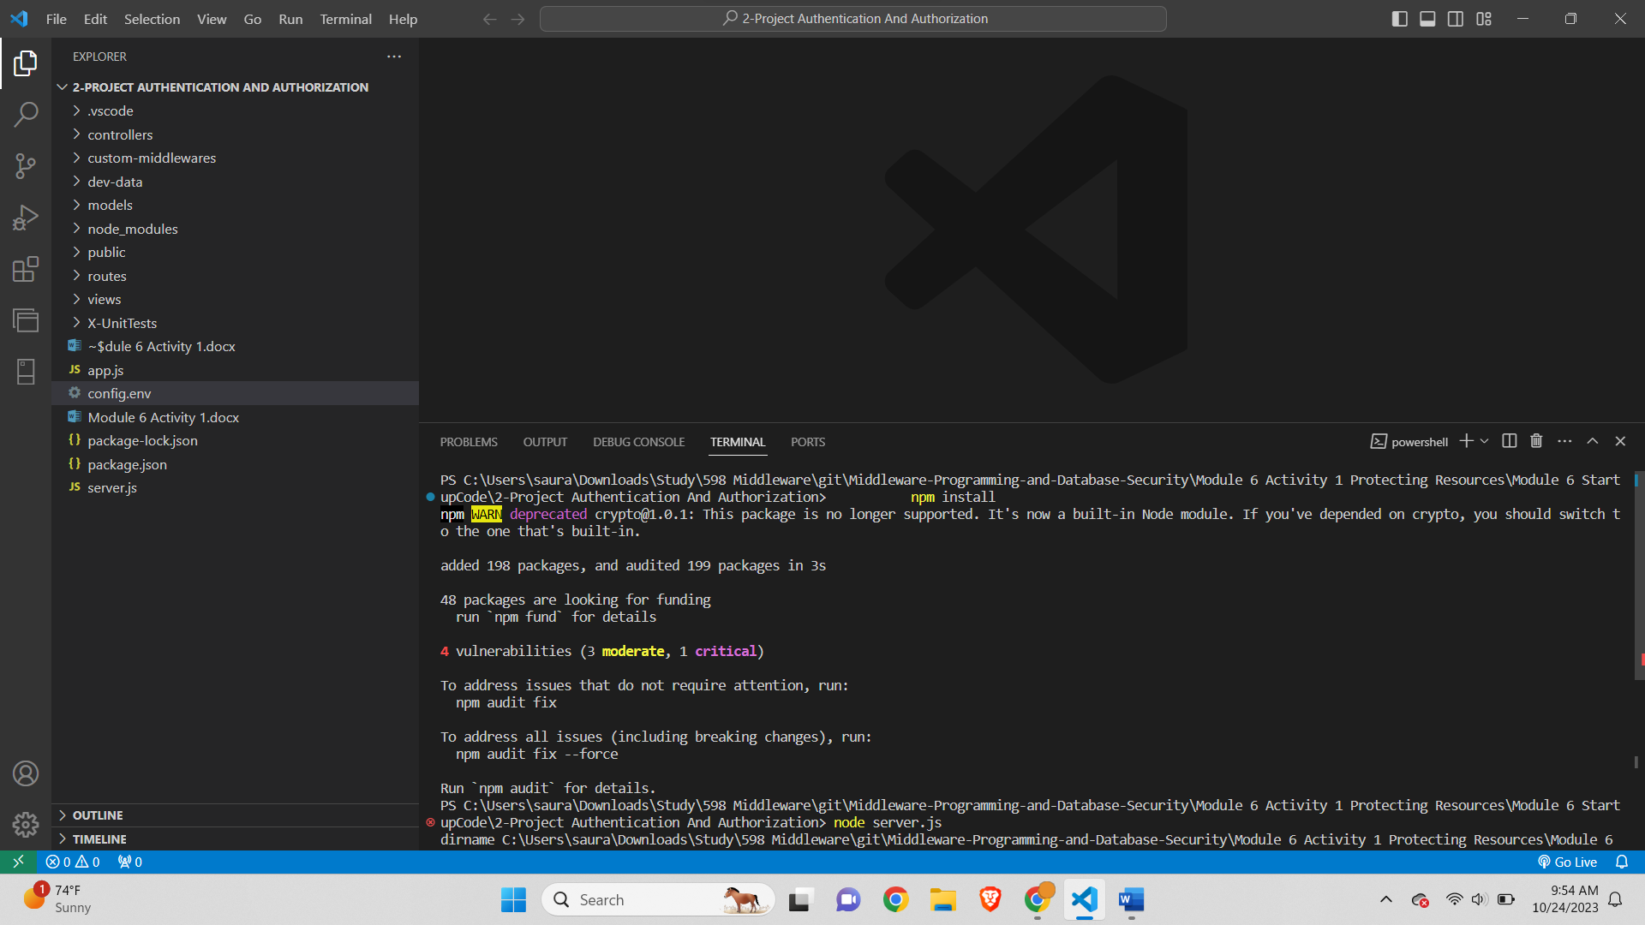

Step 2-

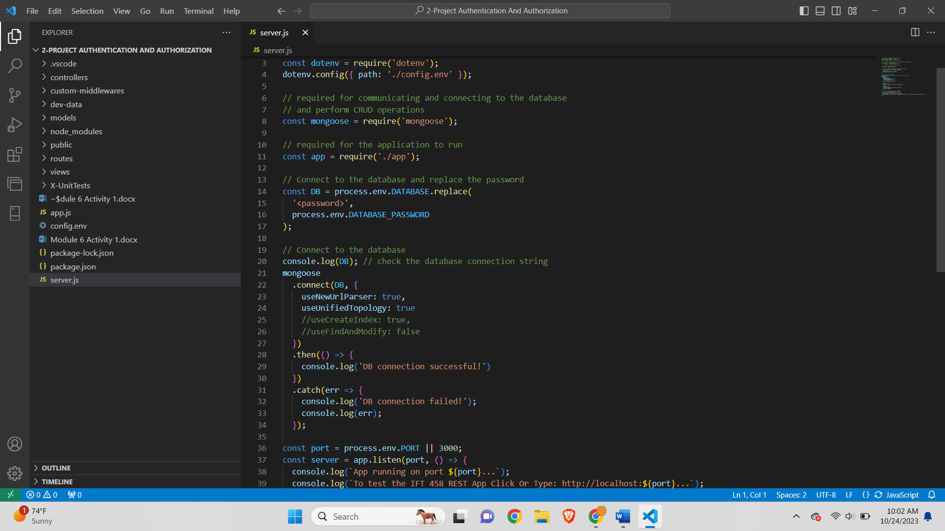

Step 3: Start Debug Mode-

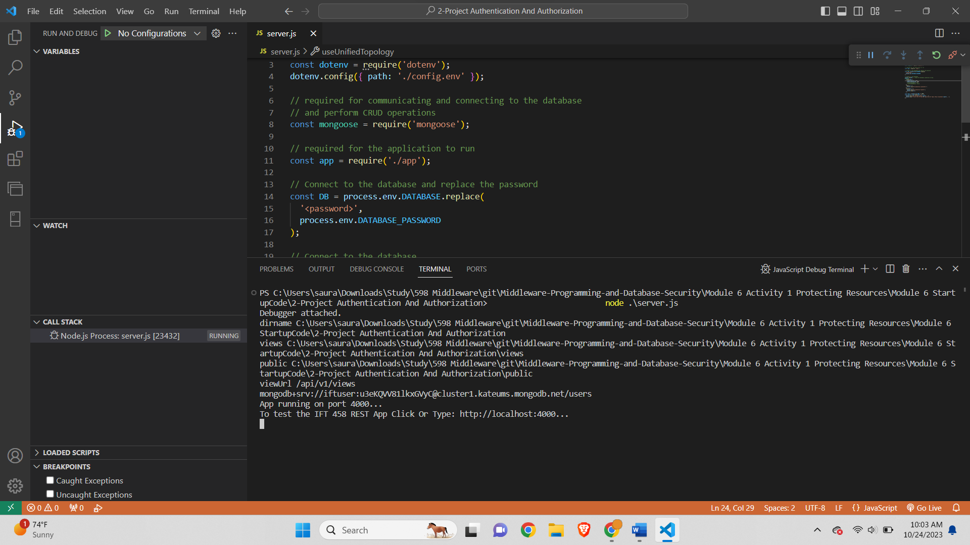

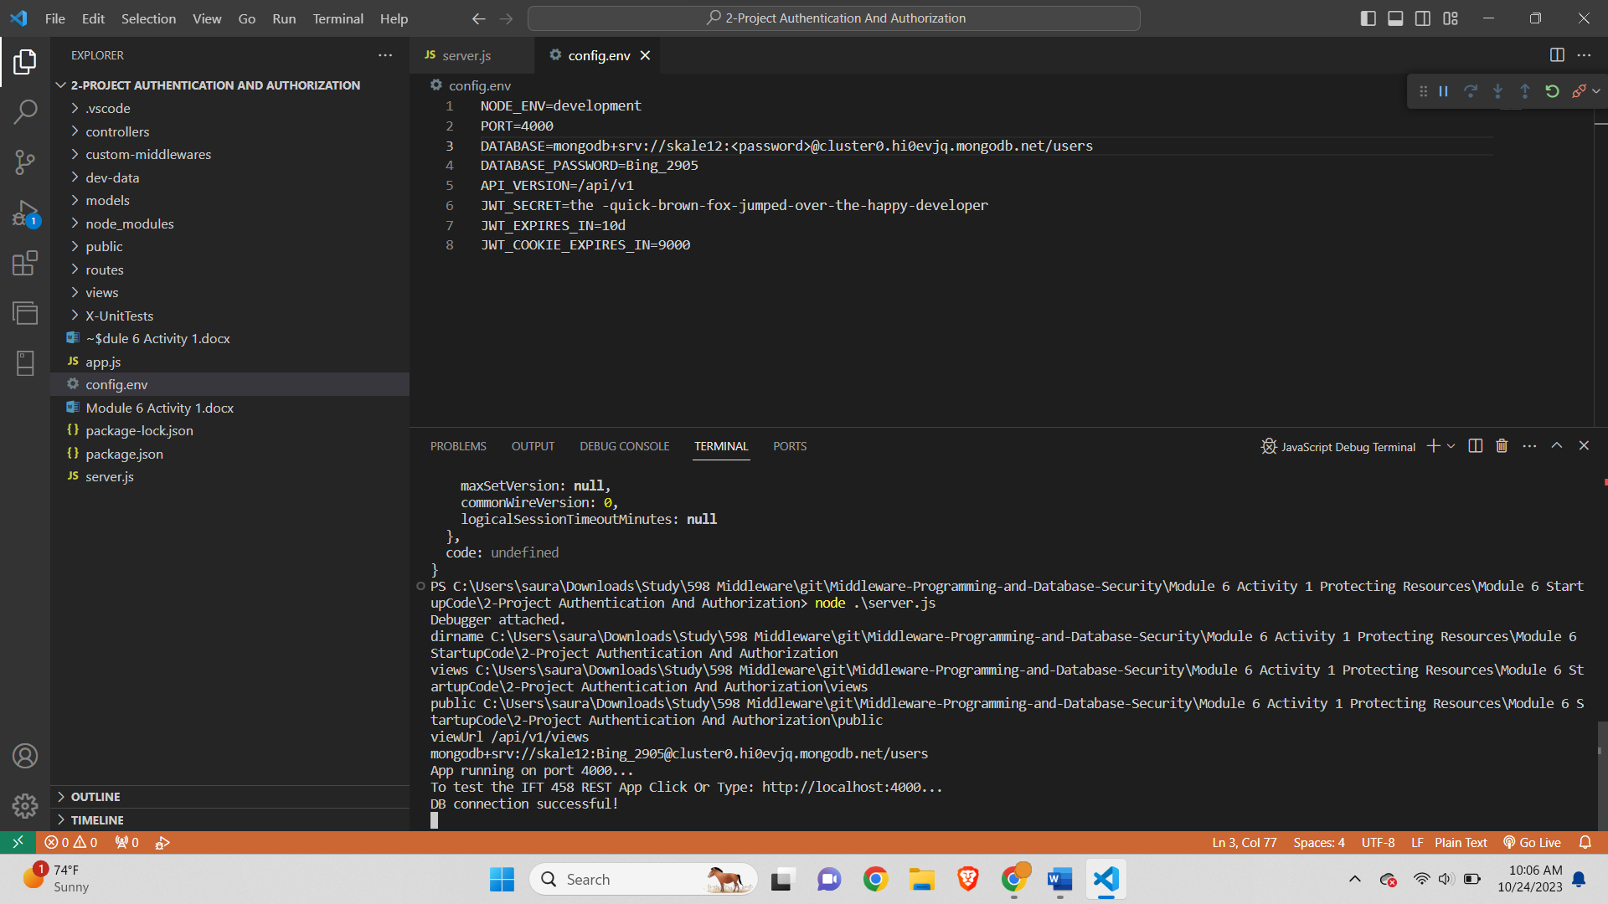

Step 4: Settings Breakpoint

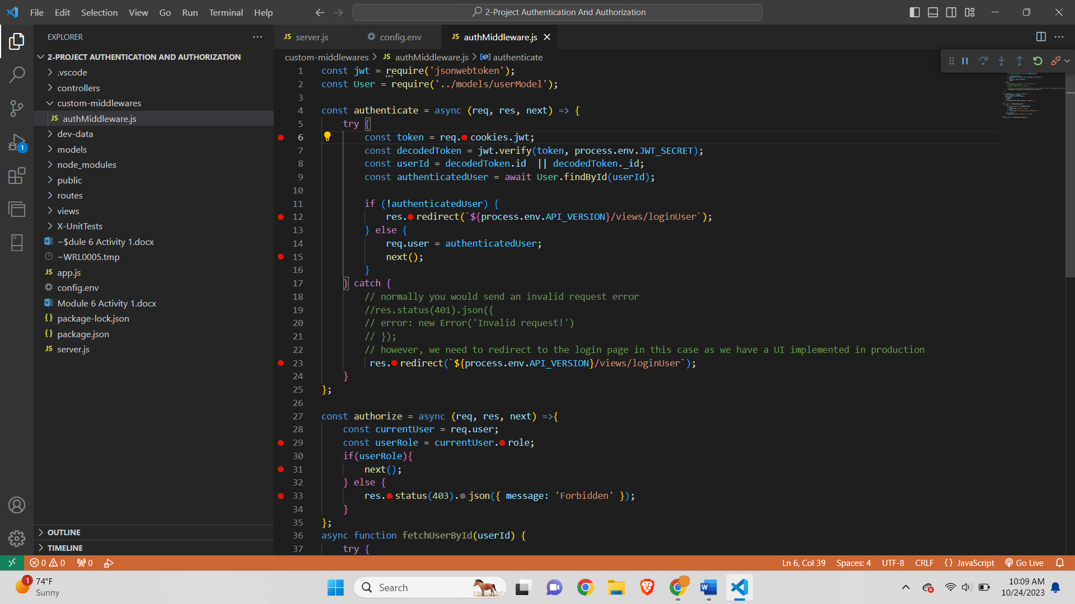

Step 5: Running the application

After signup

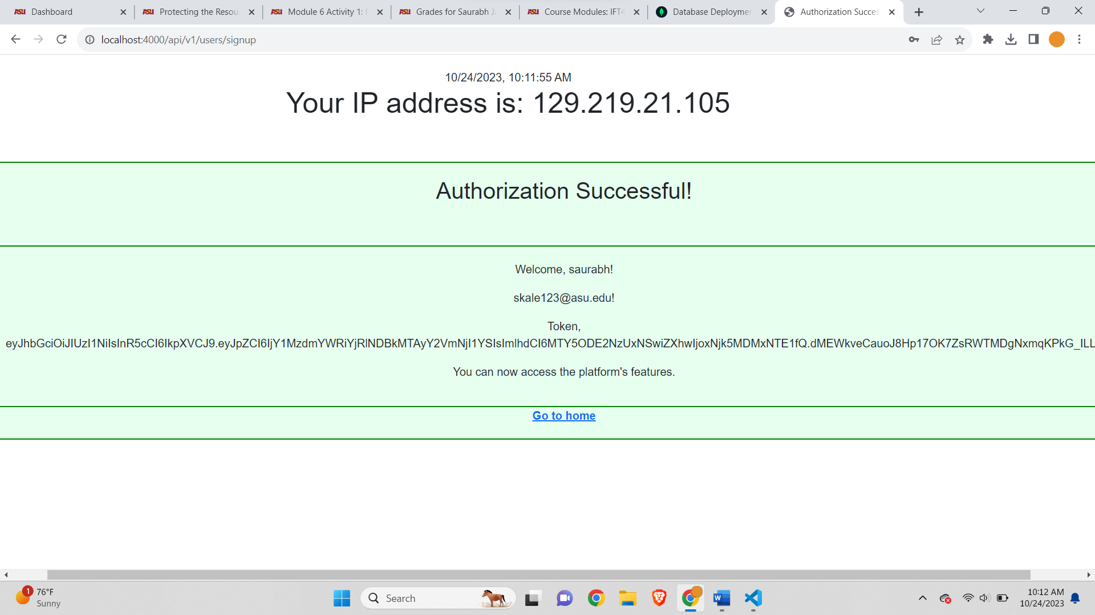

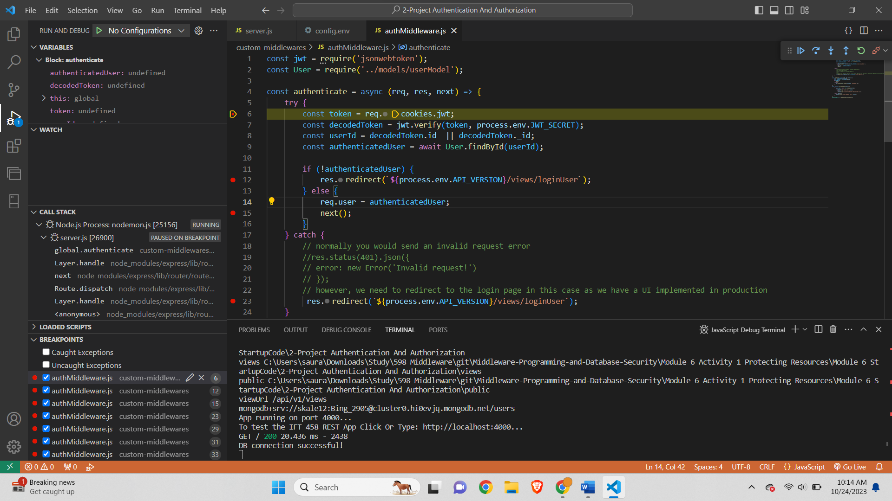



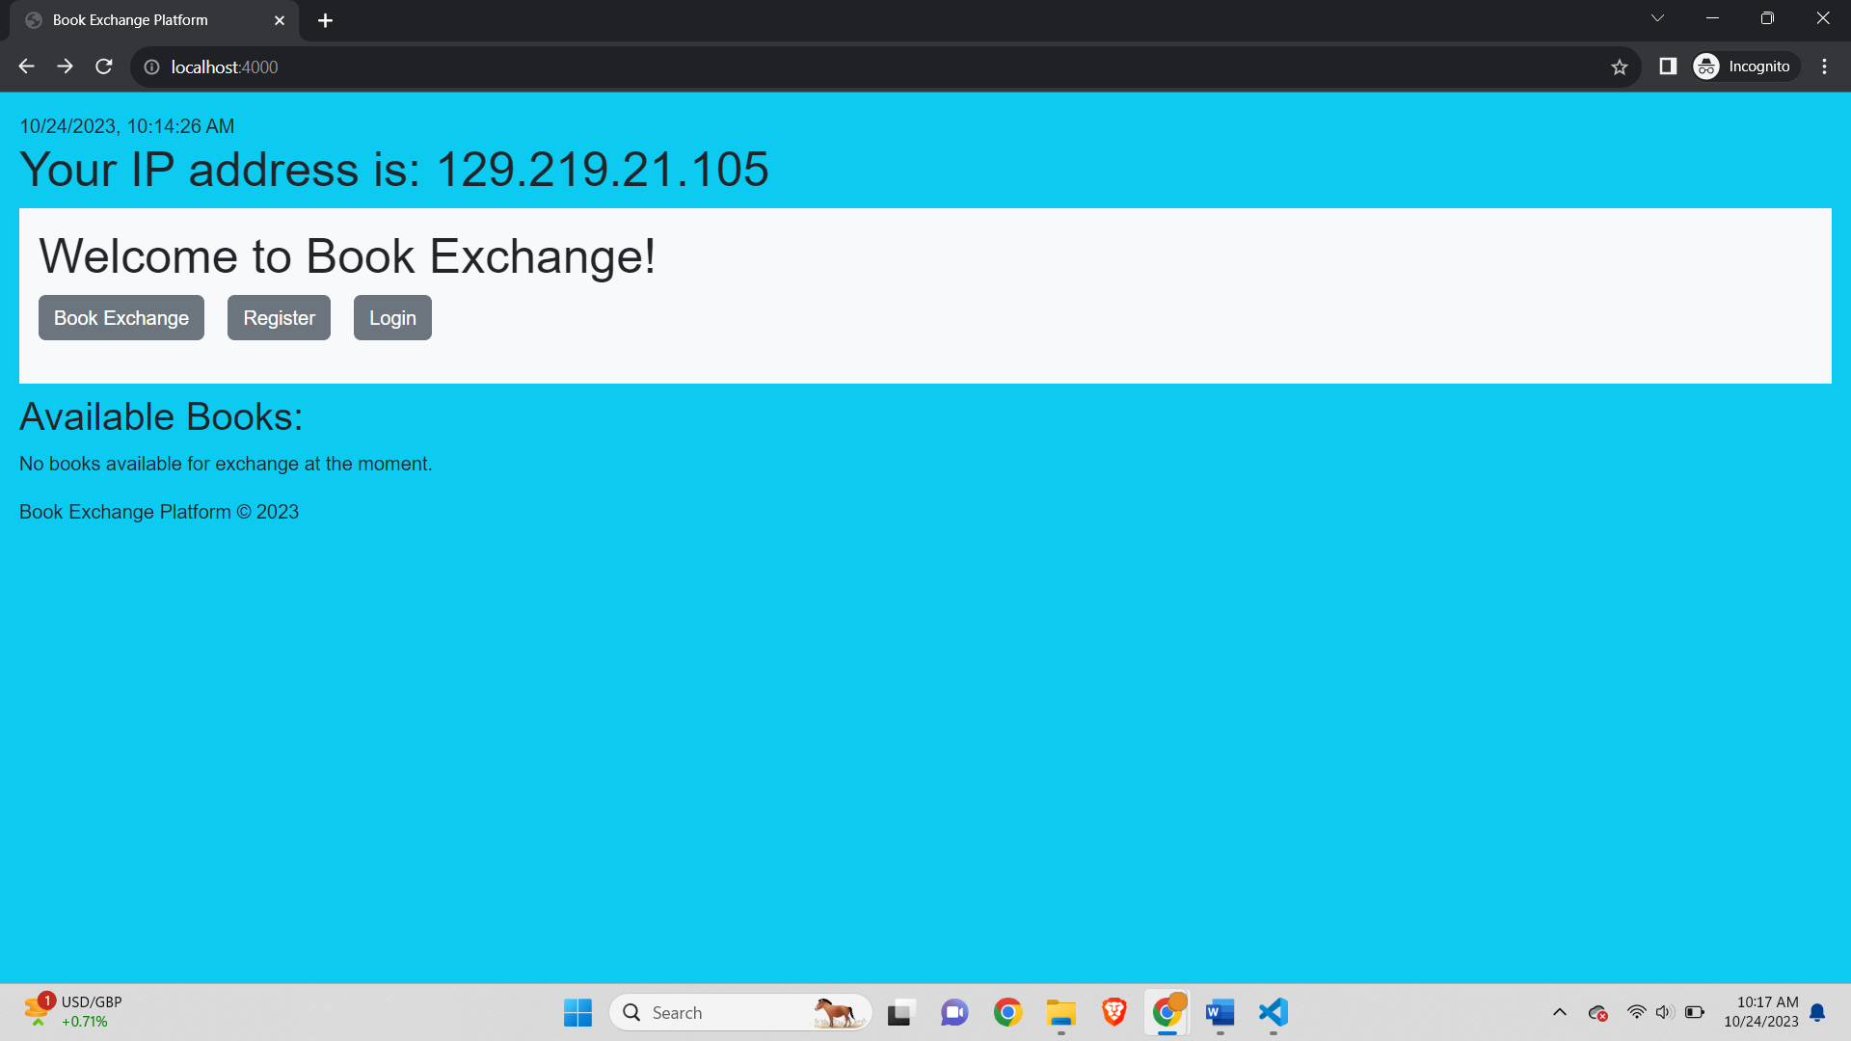

Step 6: Accessing the application

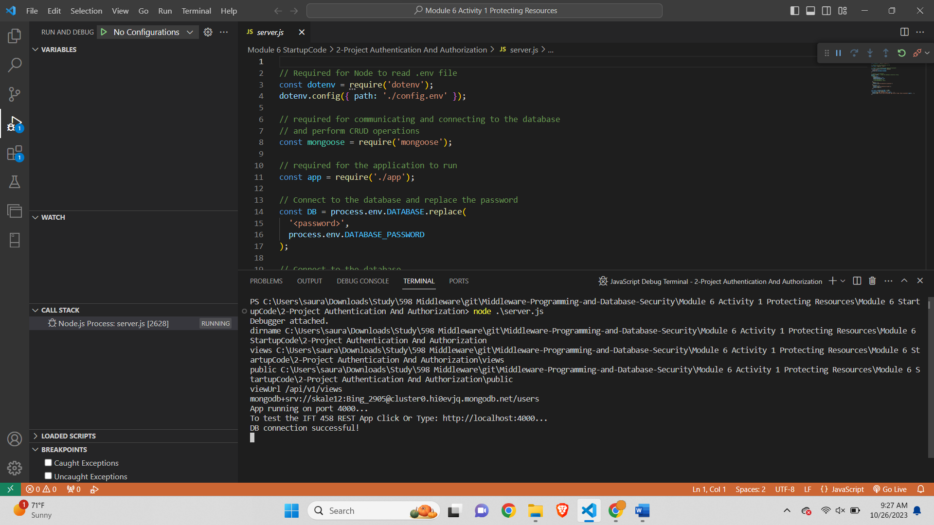

Home page-

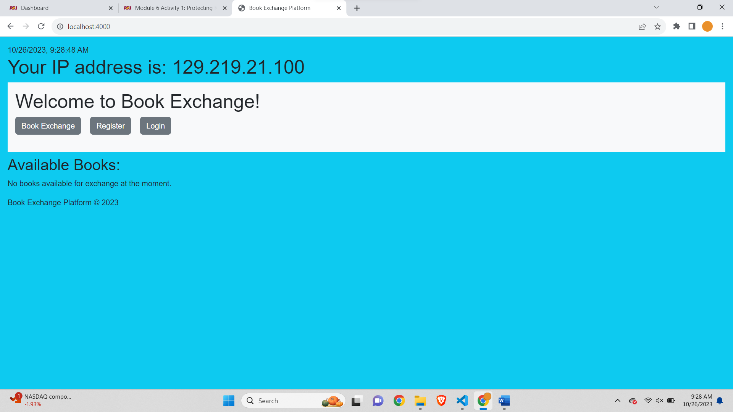

Step 6a:

Debugger stuck when clicked on Book Exchange-

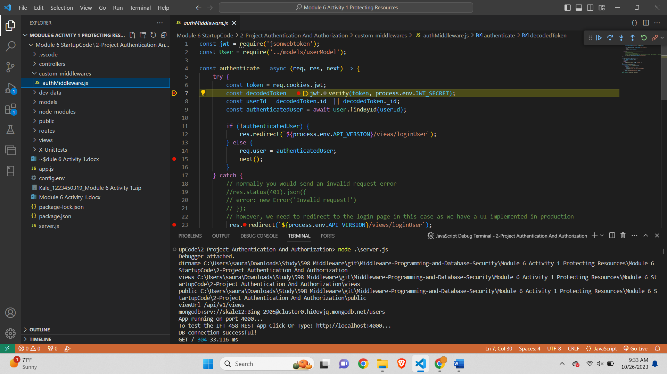

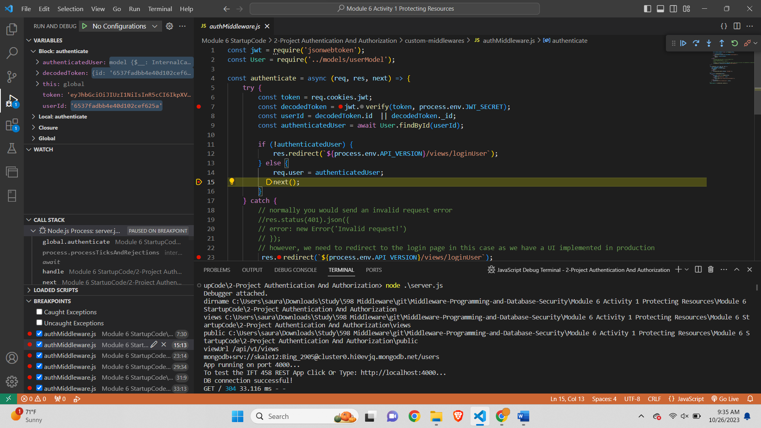

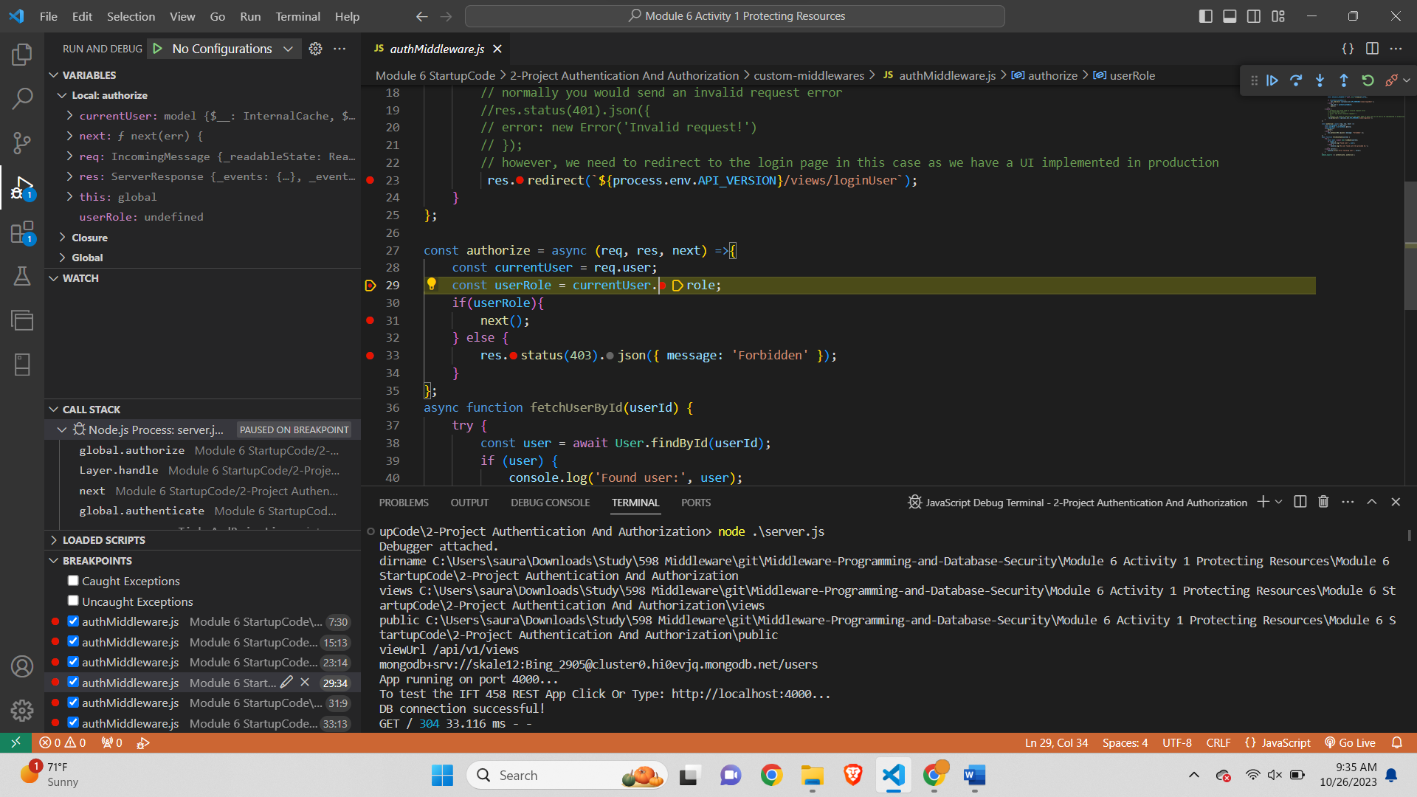

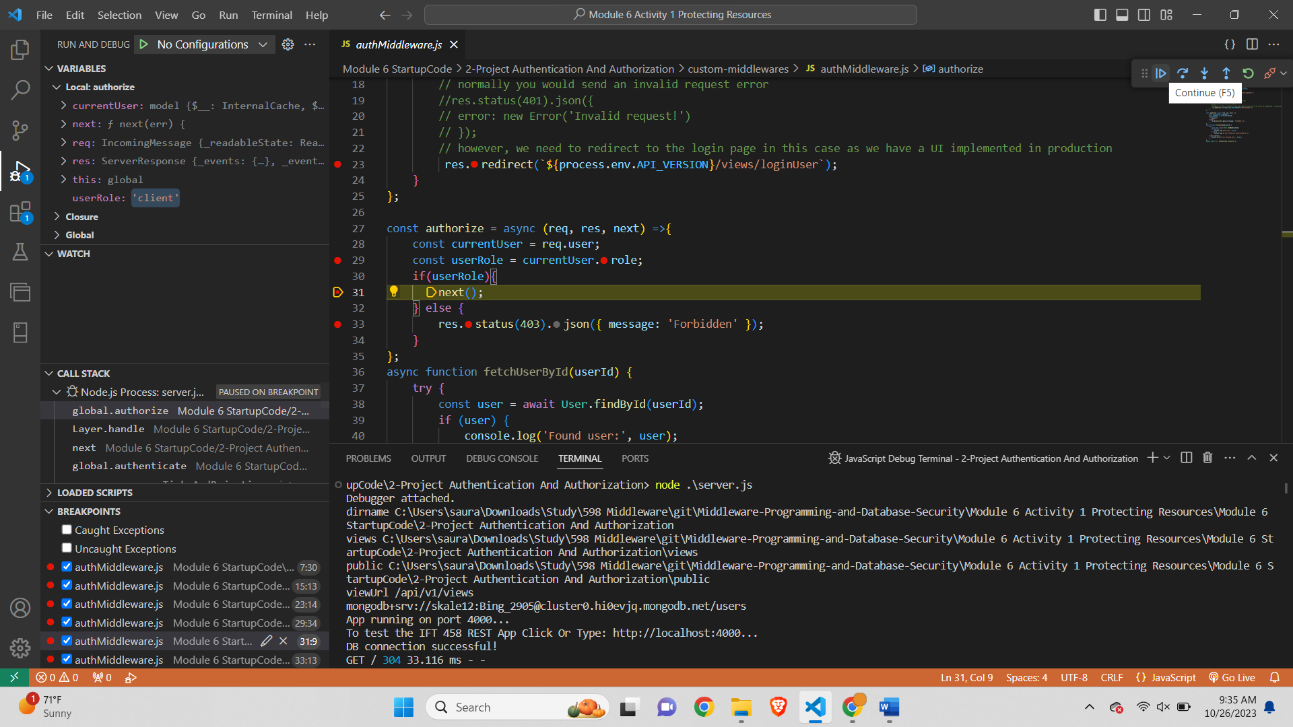

Step 7: Logging In

Login page-

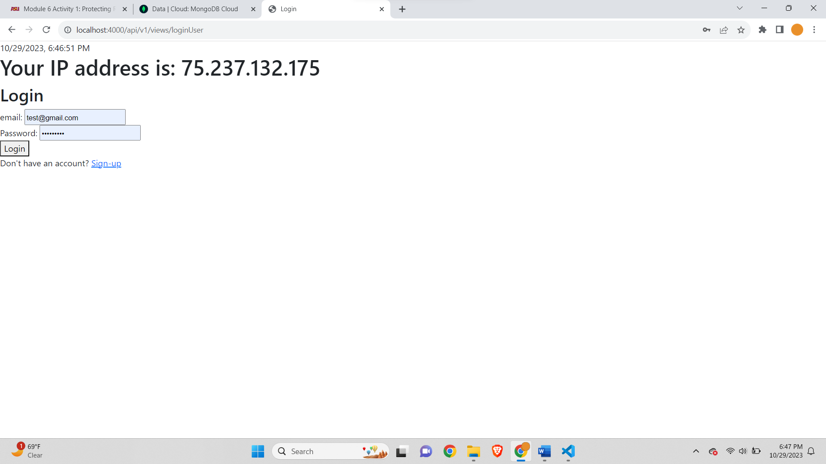

After clicking Login-

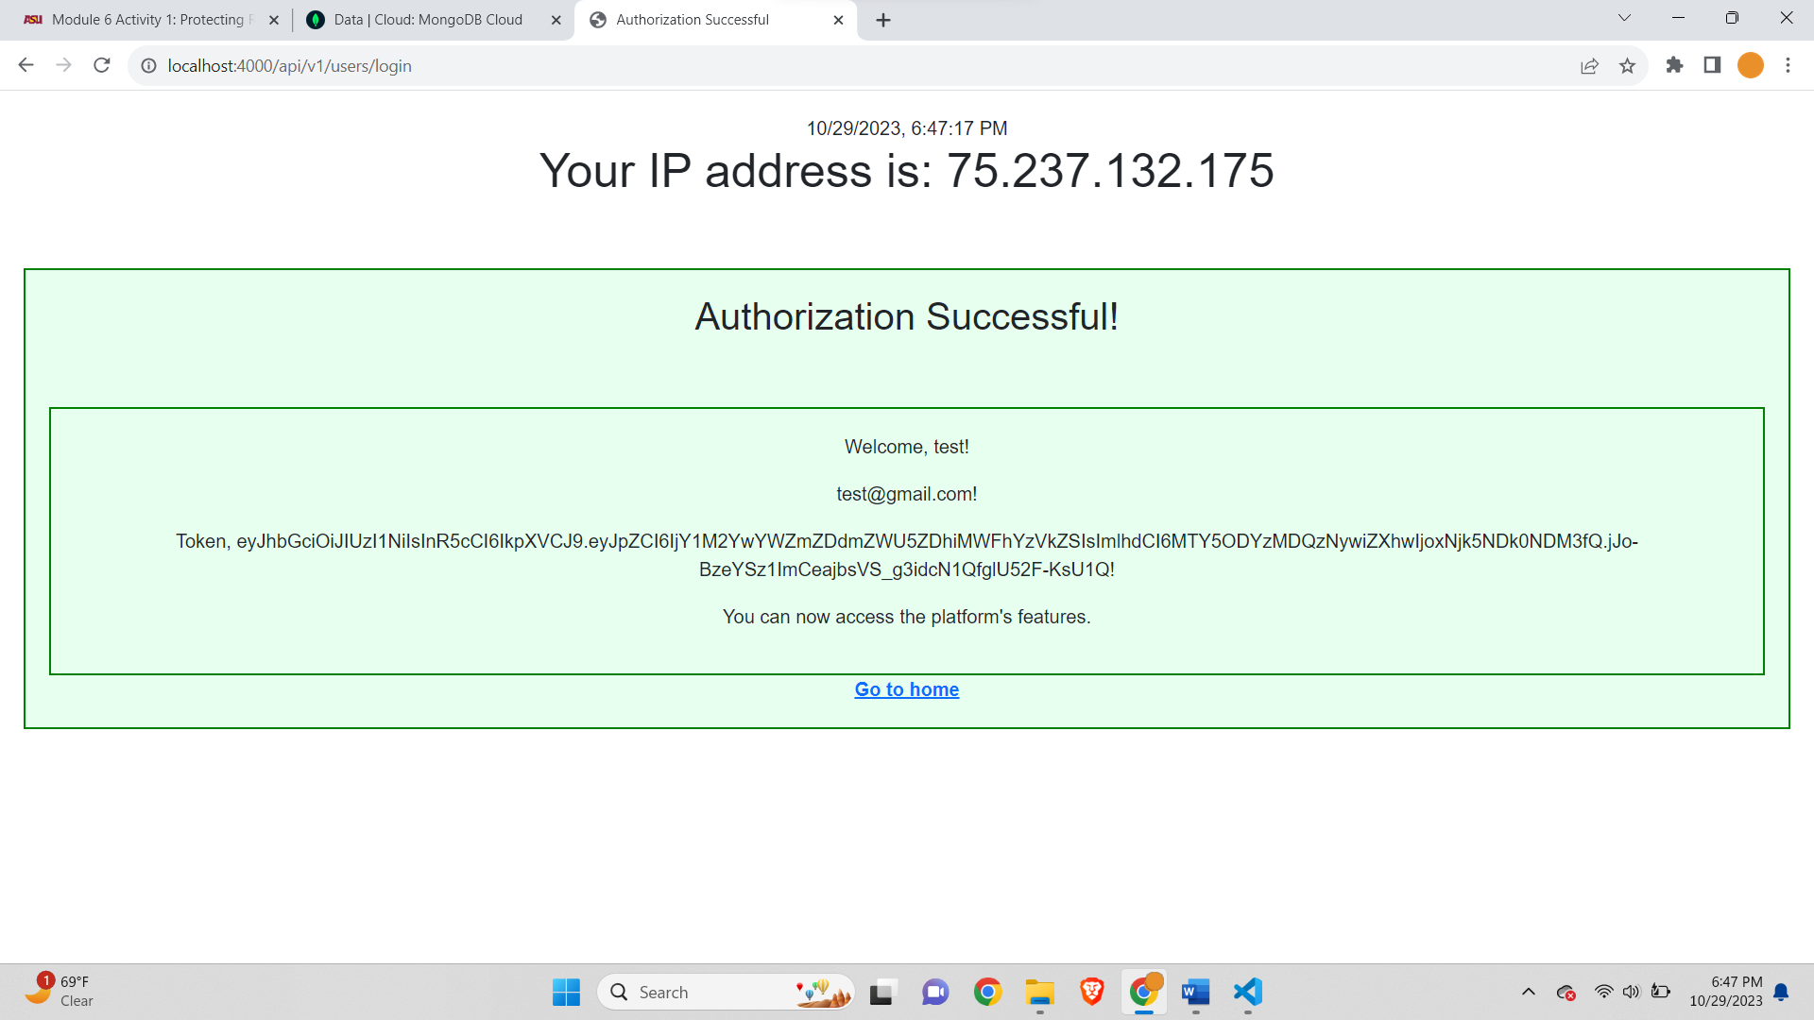

BookExchange –

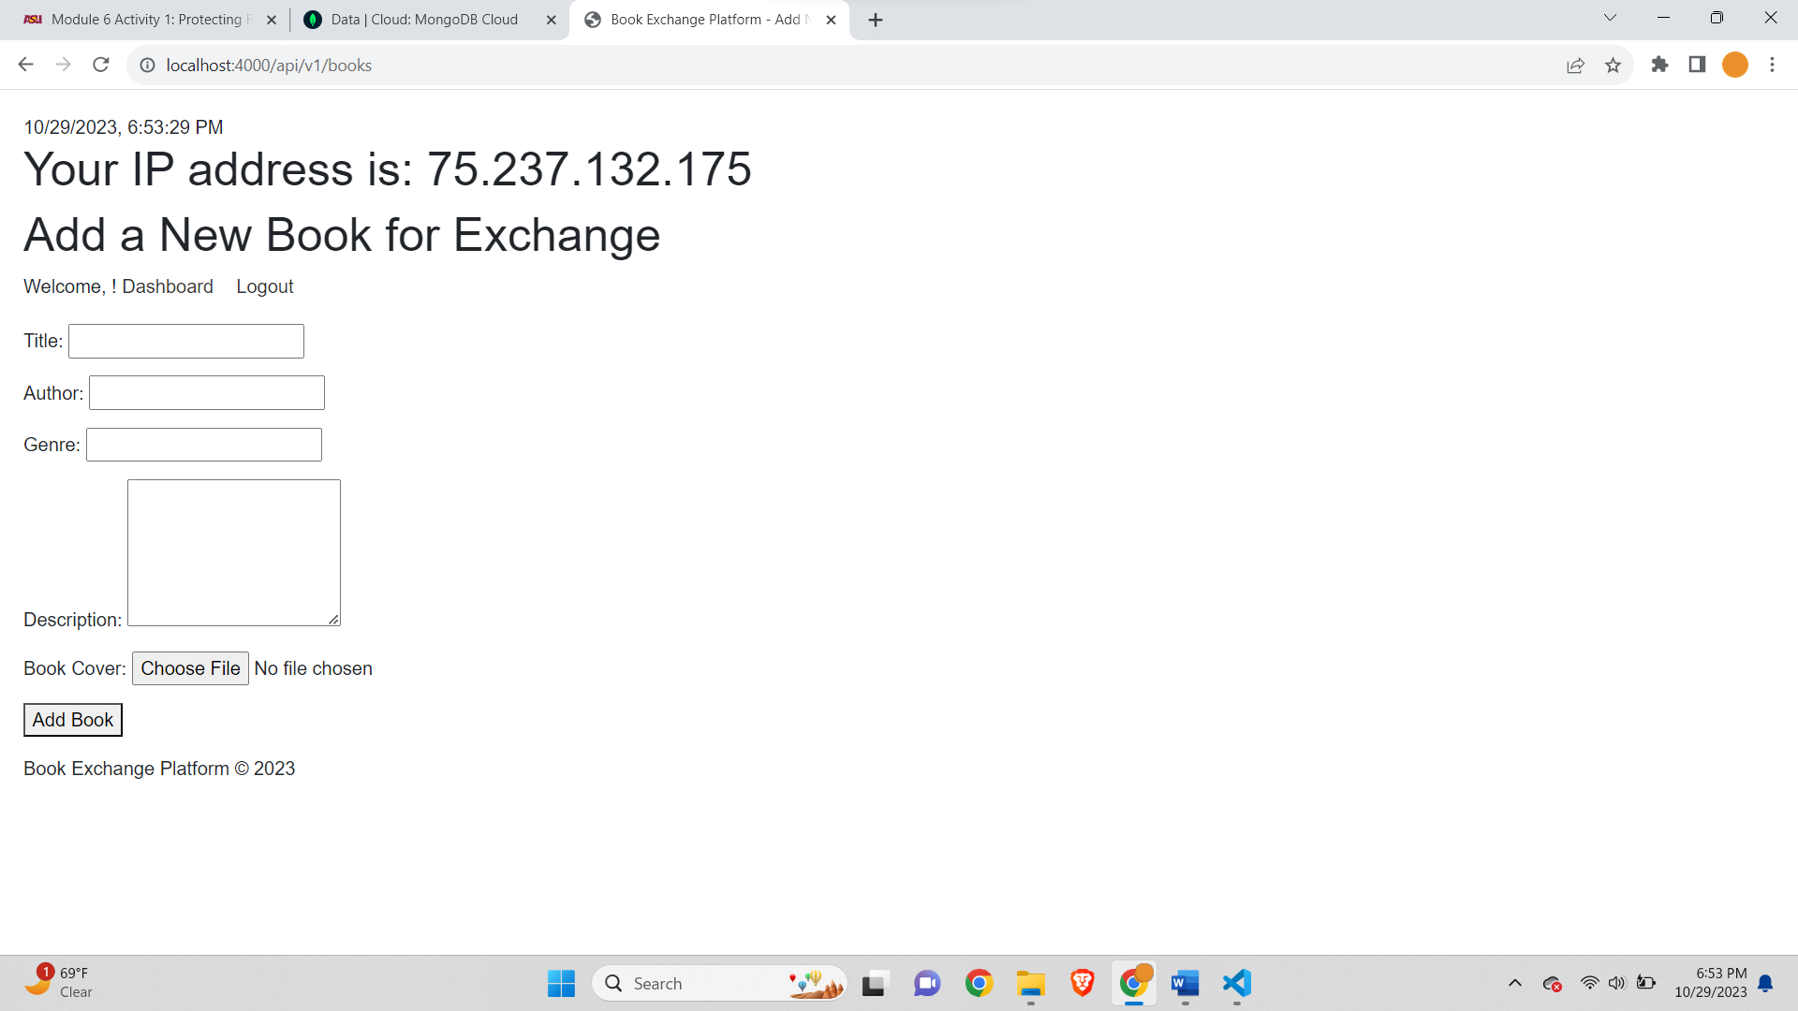

Step 8: Accessing Protected Resources

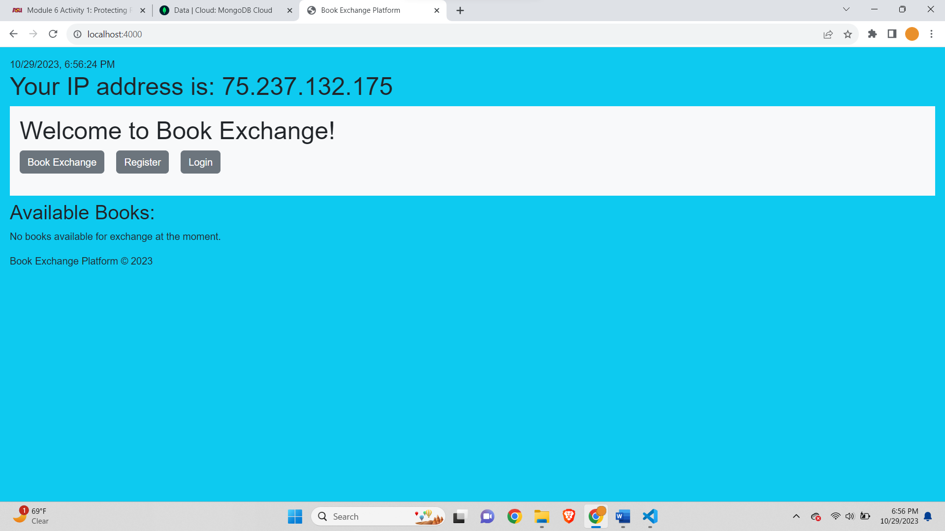

After clicking Book exchange-

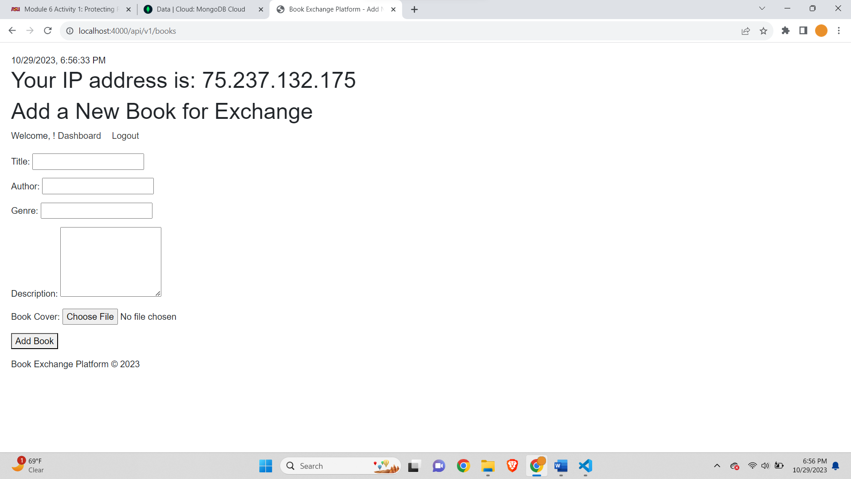

When opened in Incognito there won’t be JWS Token saved in cookies-

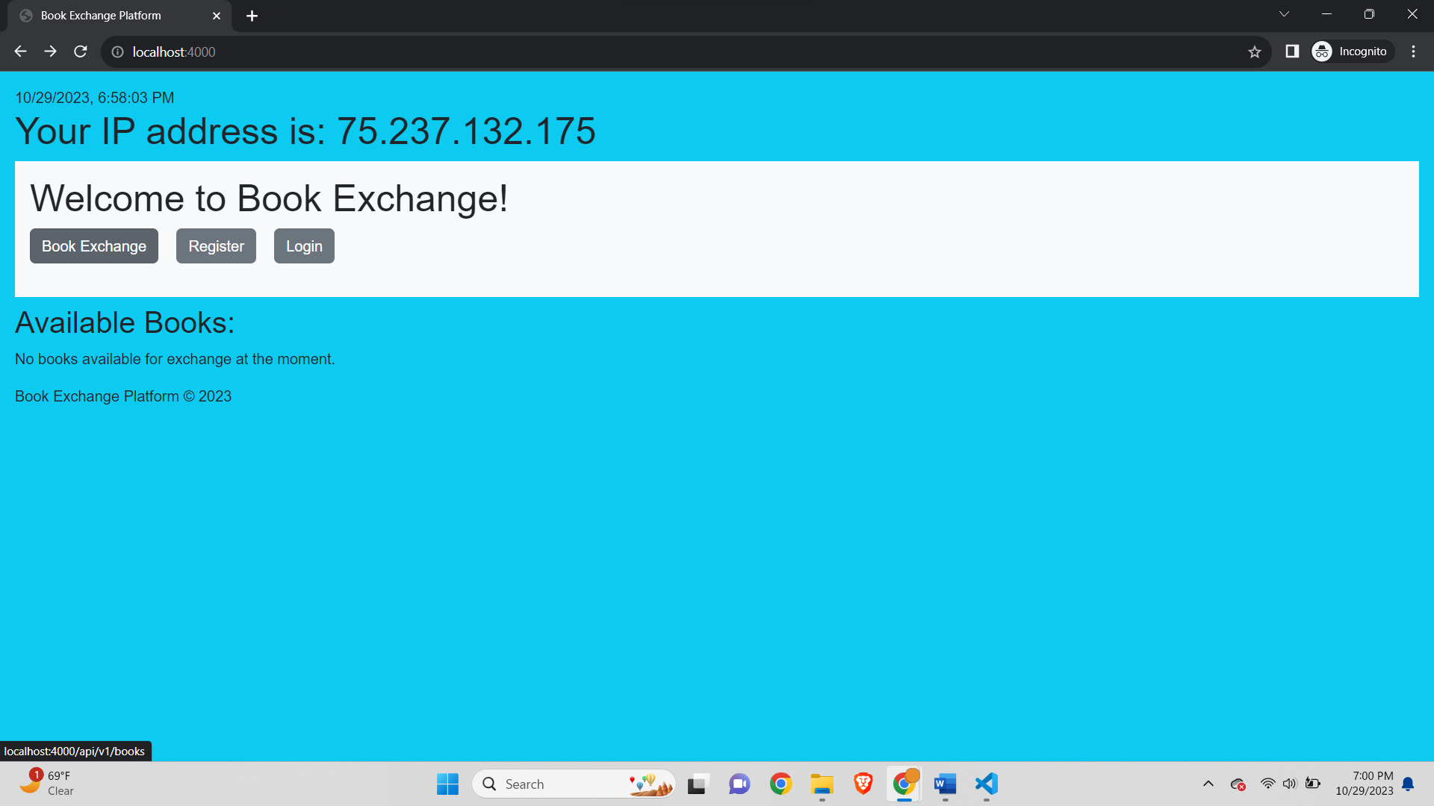

So if we click on Book exchange then it will redirect us to Login page as the JWS token won’t be found in the cookies-

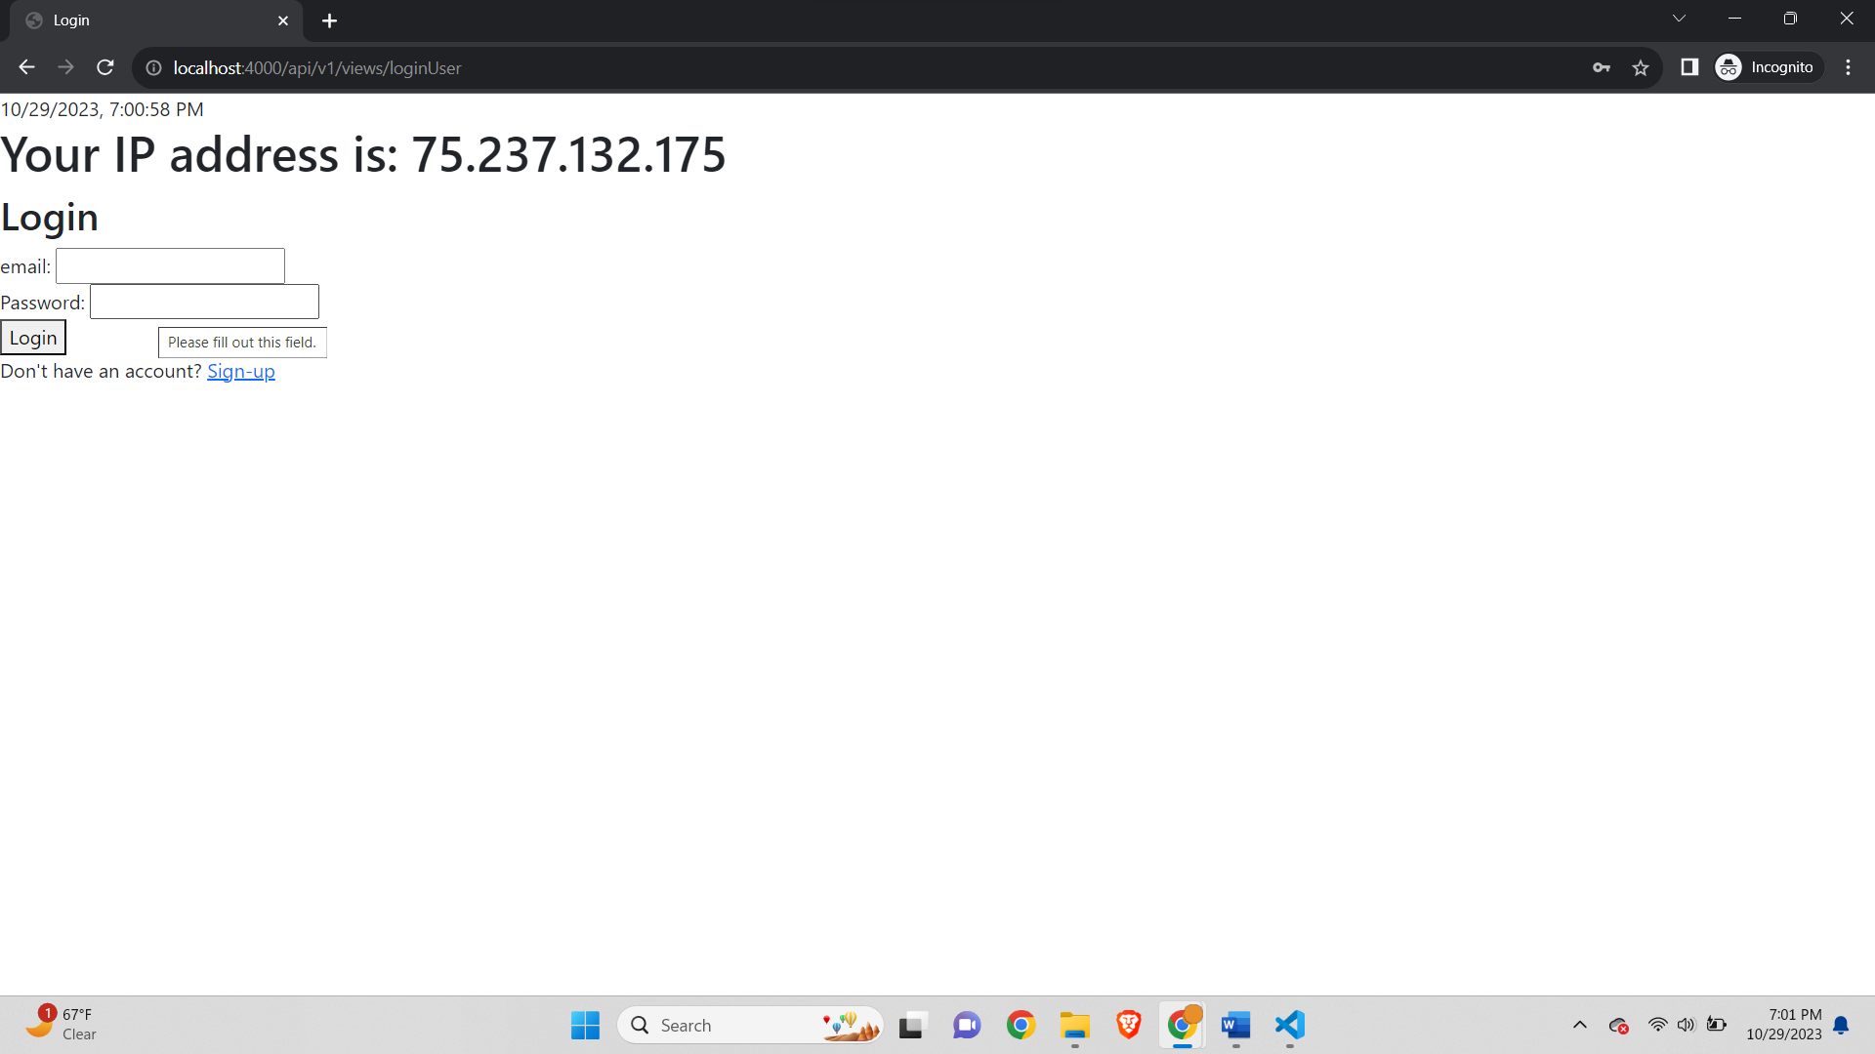

when clicking on "Book Exchange" the **authenticate** middleware in the code first attempts to verify a user's session by checking for a valid JWT token stored in a cookie. If a valid session exists, it sets **req.user** and allows access to the protected route. If a user has an active session (e.g., an unexpired JWT token), they are not required to log in again, and they are immediately directed to the "Add new book exchange" page.

Instructions-

Step 1: Ensure your application is not running-



Step 2: Restart Visual Studio Code

Closed Visual Studio-



Navigated to project directory-

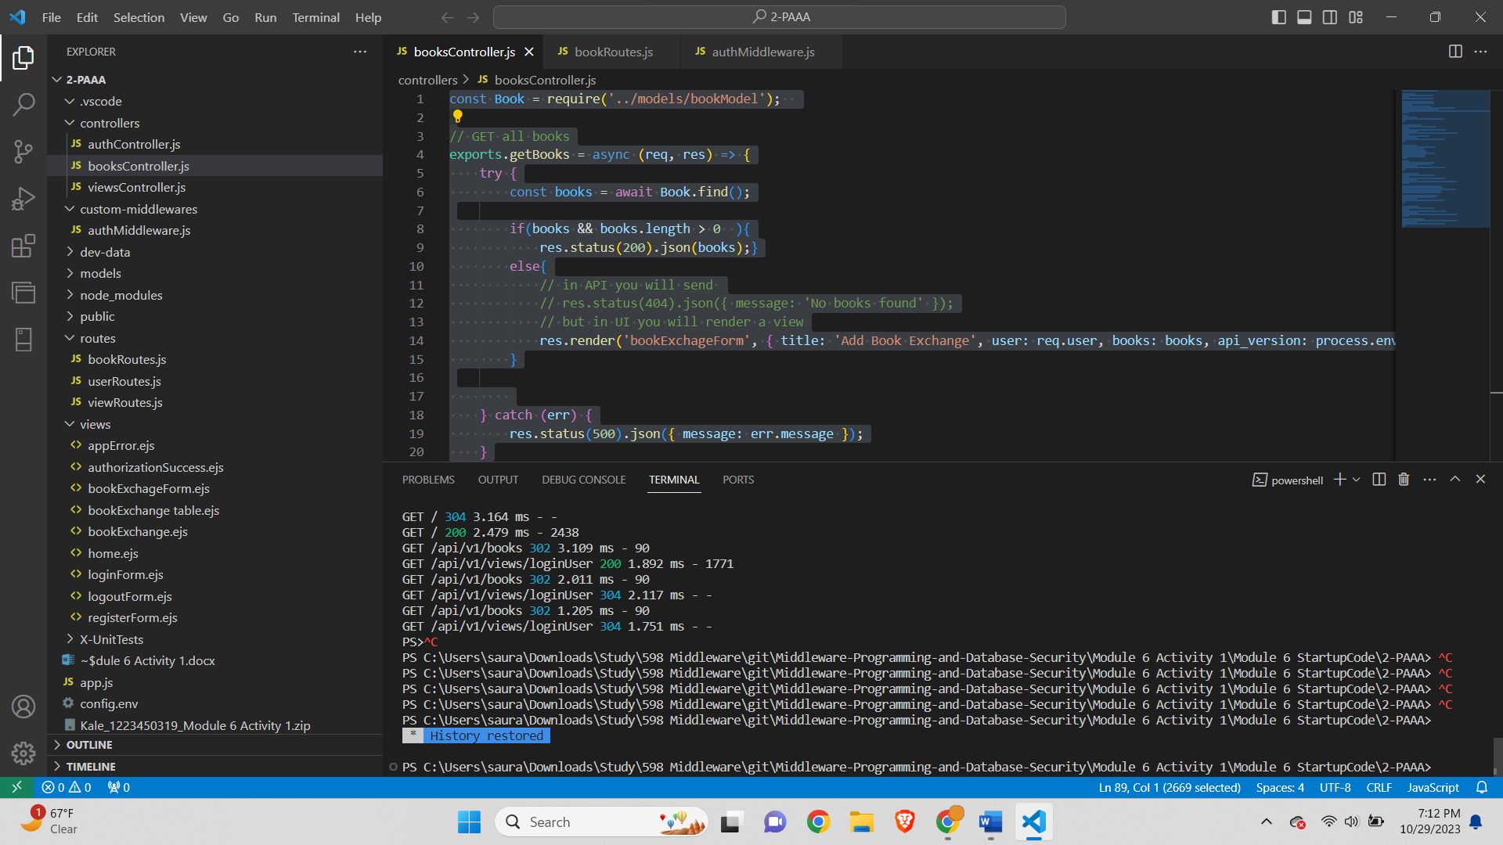

Step 3: Start Debug Mode-

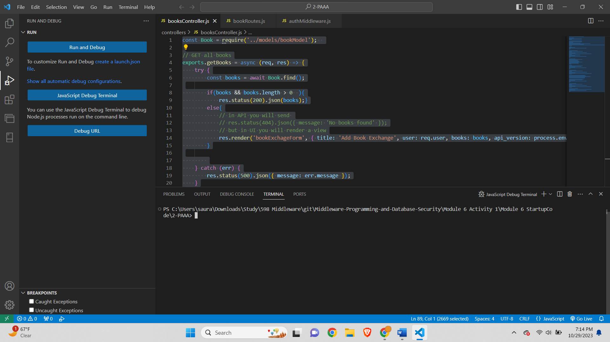

Step 4: Run the Application

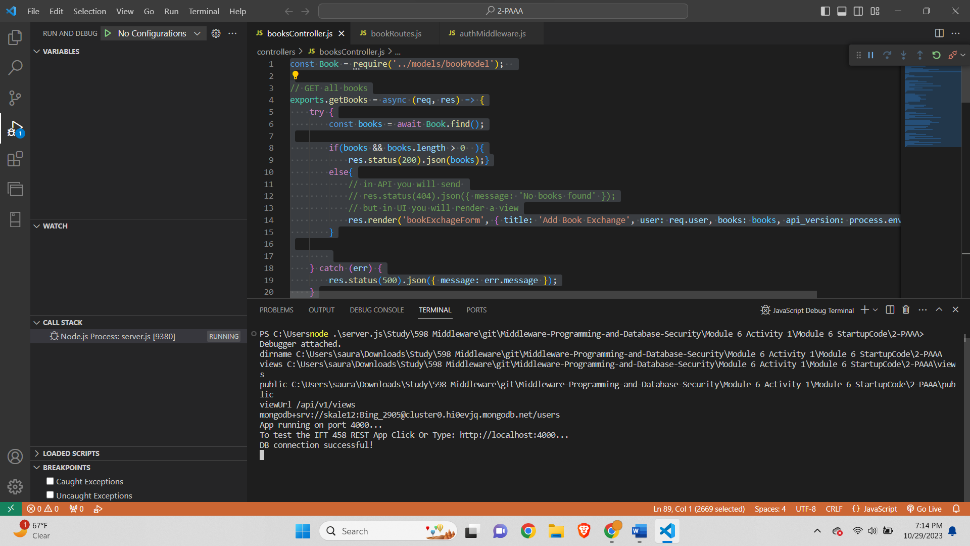

Step 5: Access the application without Logging In-

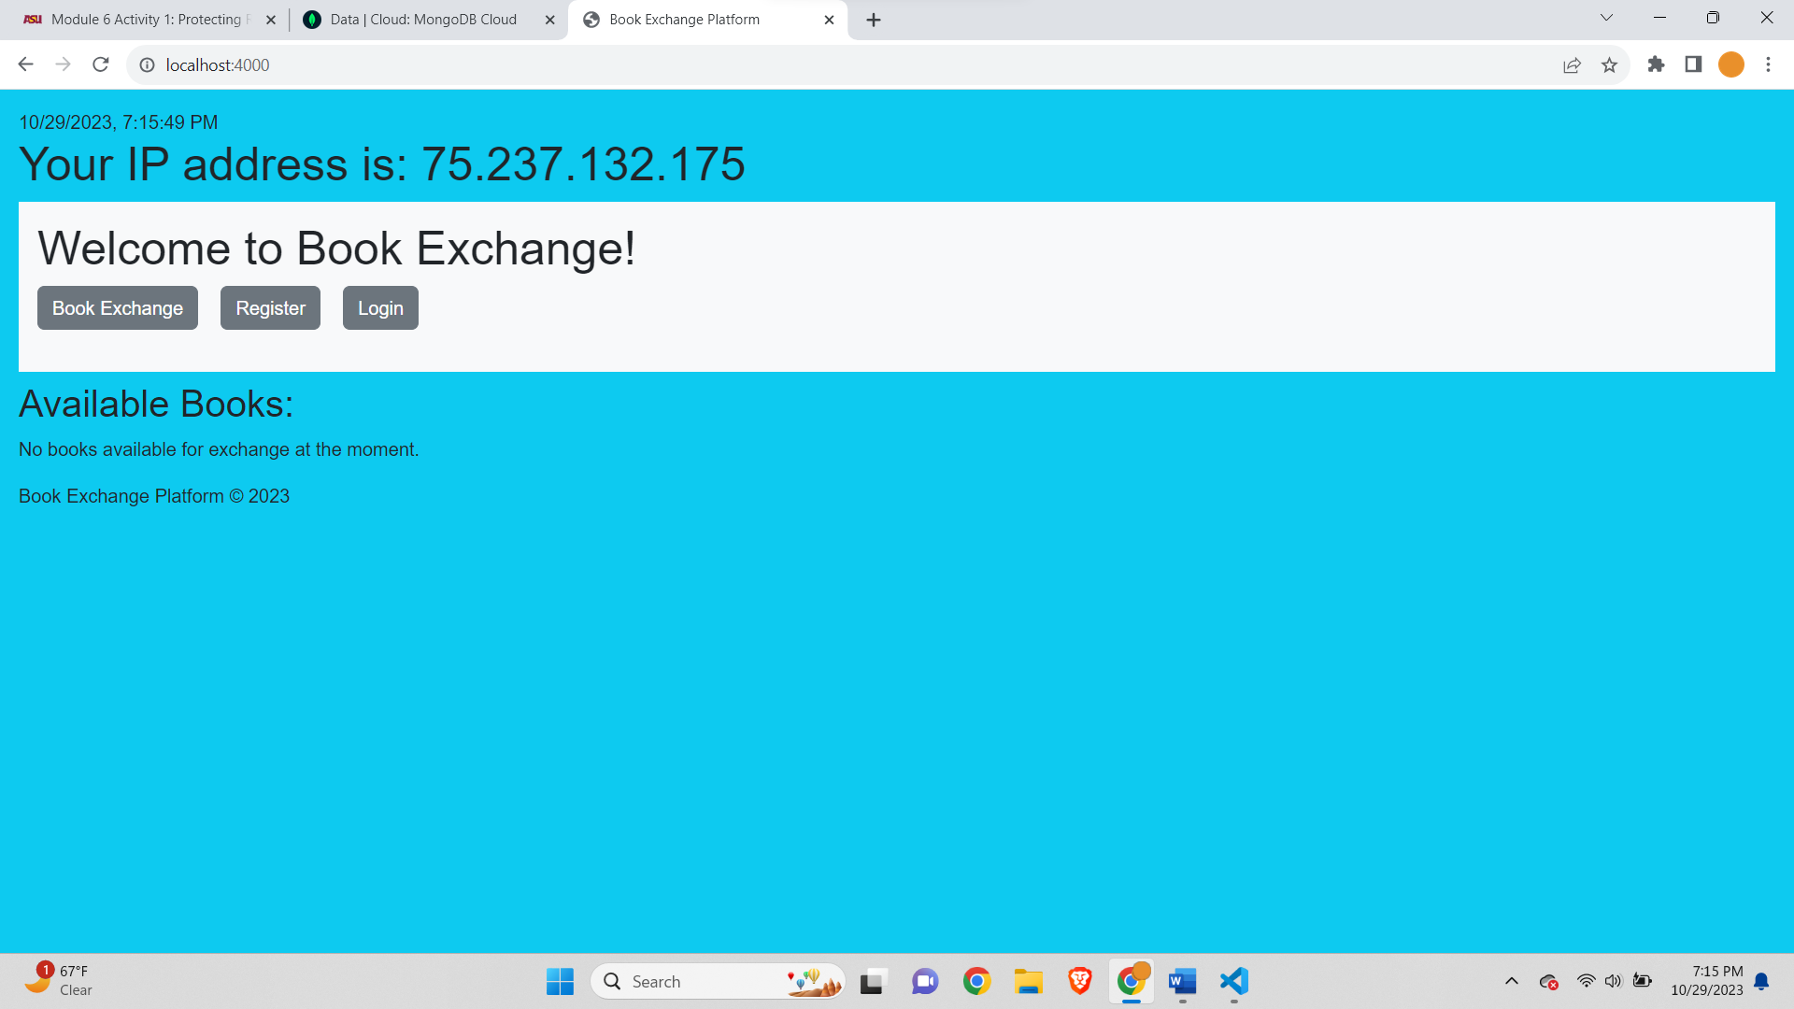

Instead of being redirected to the login page, I am able to access the "Add New Book Exchange" UI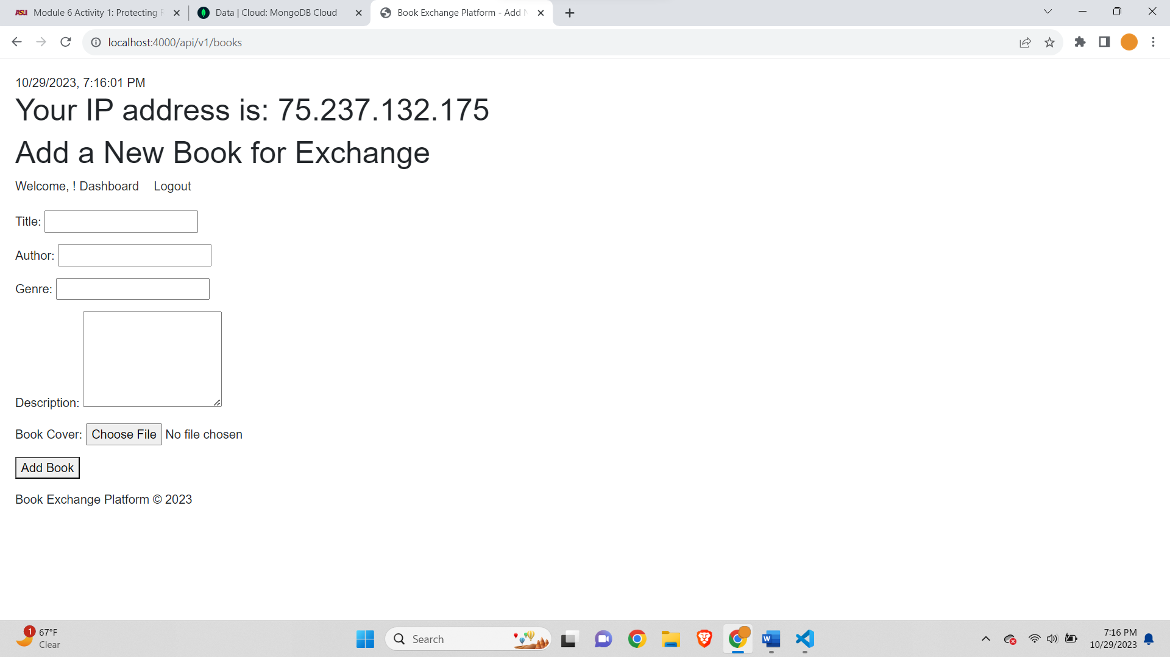

Why didn't the system ask you to log in?

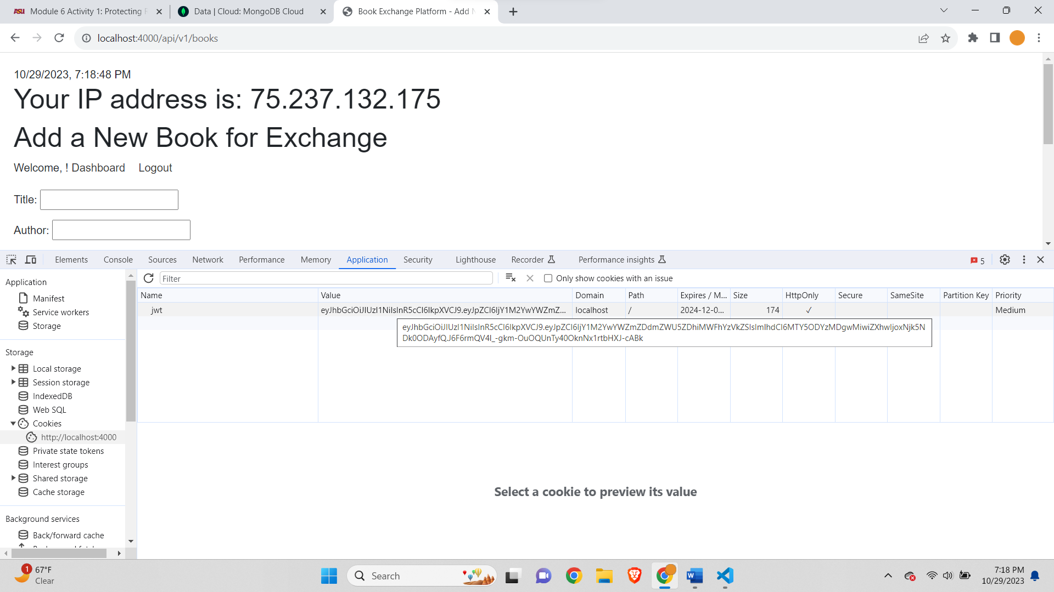

If we open the page in Incognito mode-

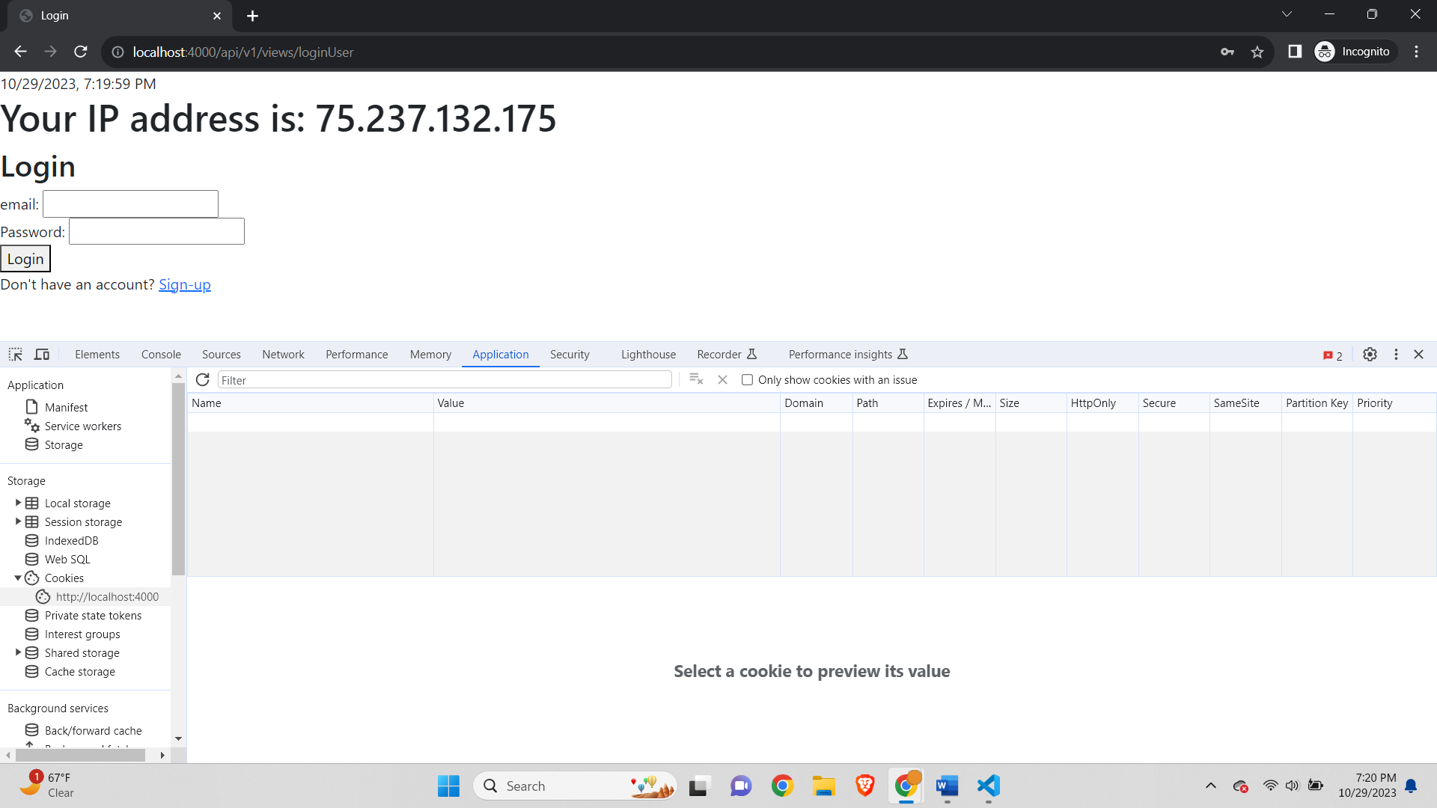

As we can see in the above images the JWT token is saved in cookies if we login once and we don’t need to login again even if stop the code and run the code again which means clearing all the variables of the code. As the JWT token is stored in cookie it won’t matter if we stop the program unless we clear the cookies of the browser or till the expiry of the token which is 10 days as we have configured in config.env. When we open an Incognito mode in browser there is no cookies already stored in that session and hence it does not find the JWT token which was stored in the normal browser cookie so it takes us to login page instead of Add new book for exchange page.

2. Verify the token-

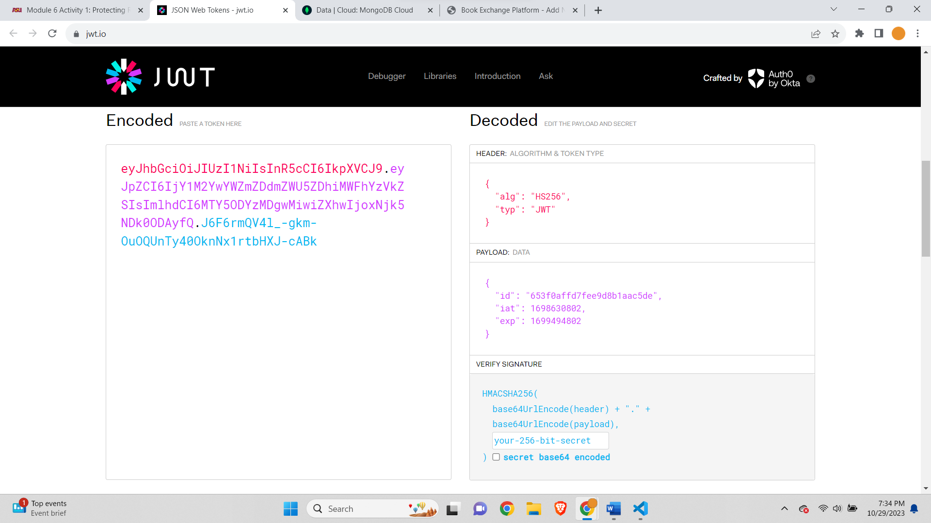

As shown in the JWT token payload the ID is the ID of the user-

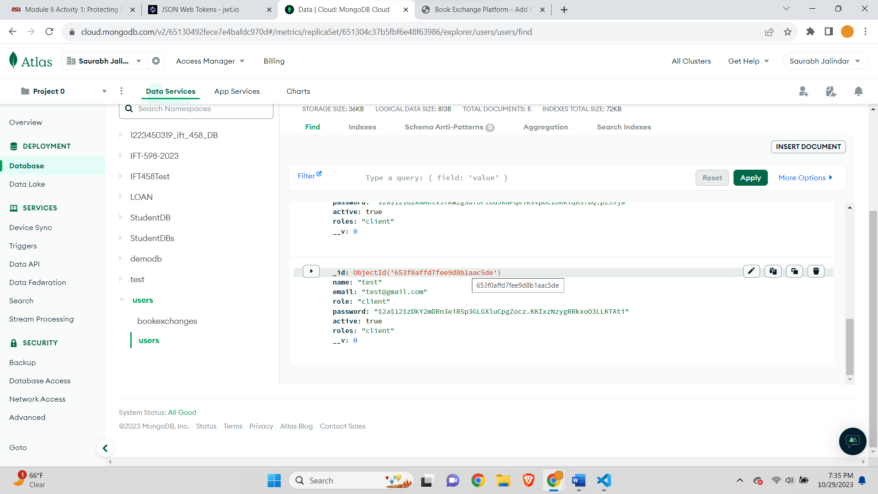

Request Header-

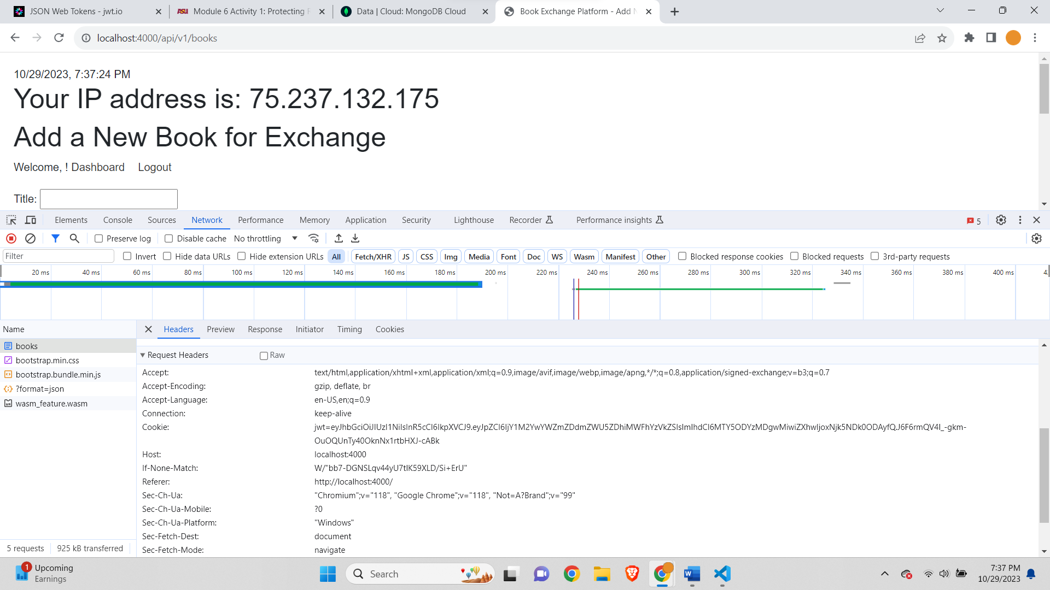

The captured image contains the JWT token in the Cookie of request Headers.

What is JWT and its role in security?

JWT, or JSON Web Token, is a compact, self-contained means of representing and transmitting information between parties as a JSON object. It is used as a token to authenticate and verify the integrity of information during communication. JWTs are widely employed in security systems, particularly for authentication and authorization purposes. They consist of three parts: a header, a payload, and a signature.

In terms of security, JWT plays a pivotal role by providing a trusted and standardized mechanism for secure data transmission. The header typically defines the algorithm used for signature verification, while the payload contains claims about the user and additional data. The signature is generated using a secret key and is used to verify that the sender of the JWT is who it says it is and to ensure the token has not been tampered with during transit. JWTs are stateless, which means they don't require a server to store session information. This simplifies scalability and load distribution, making them particularly useful in modern web applications and microservices.

One of the significant advantages of JWT is that it can be used to verify the identity of users and secure API endpoints by confirming that the user possesses a valid token. This enhances security by preventing unauthorized access and ensuring data integrity. JWTs are also versatile, as they can be used in various scenarios, including single sign-on (SSO) solutions, mobile app authentication, and secure data exchange between parties. However, it is crucial to handle and store JWTs securely, as a compromised token can lead to security breaches. Overall, JWTs are a valuable tool in securing modern web and API-based applications.

Line Diagram-

